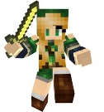
OPTIONAL ACTIVITY
design a MineCraft MAP ON THE BLANK SIDE and add notes below

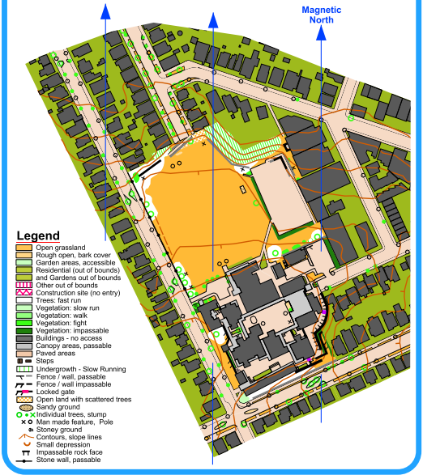
NOTES

