COMPETITION TASK
Use your imagination to write a short Minecraft story (up to 500 words). You can use optional dialogue, you can set the story in any time period, you can recreate scenes or settings based on your favourite story or take on the role of a main character or act out a scene from your own game play in Minecraft.
Bring your entry into school so it can be judged. Certificate of participation for all entries.
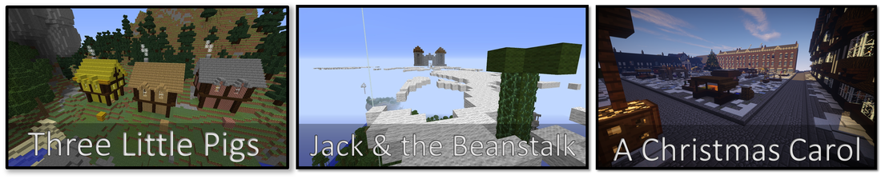

Below is a list of sentences starters and a list of verbs / adverbs that may help you with your story:

Sentence Starters
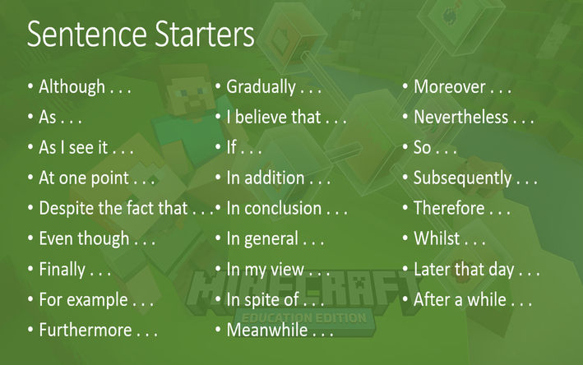

Prepositions
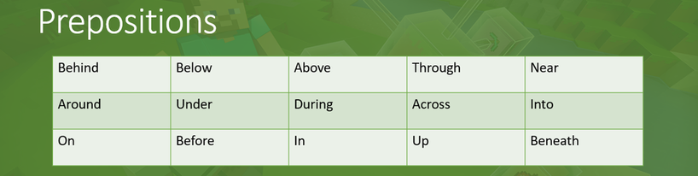

Adverbs
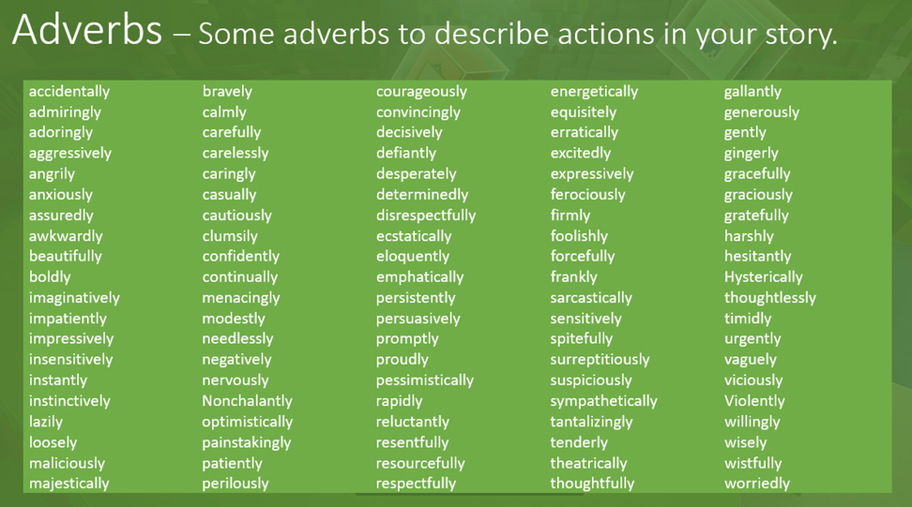

Verbs
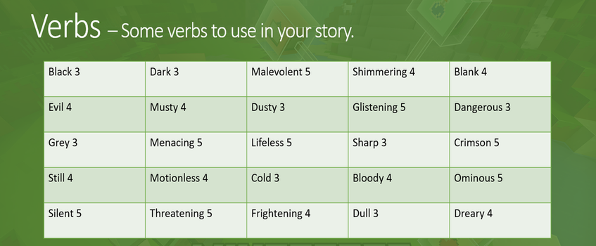

NOTE: Extra credit is given for the use of adverbs and complex words such as 'Shimmering' and 'Ominous'.

