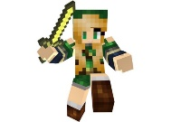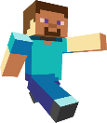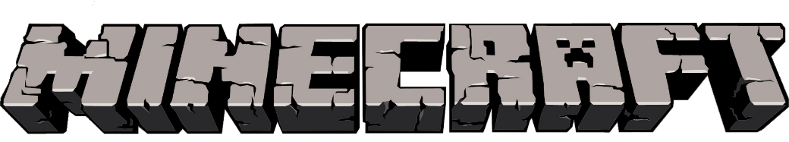

design Your Own MineCraft Character

**CHARACTER NAME:**

**ARMOUR:**

**WEAPONS:**

**SKILLS:**

**ENEMIES:**

**Explain your game idea for this character**