

Post-16 Options:

How does it all work?

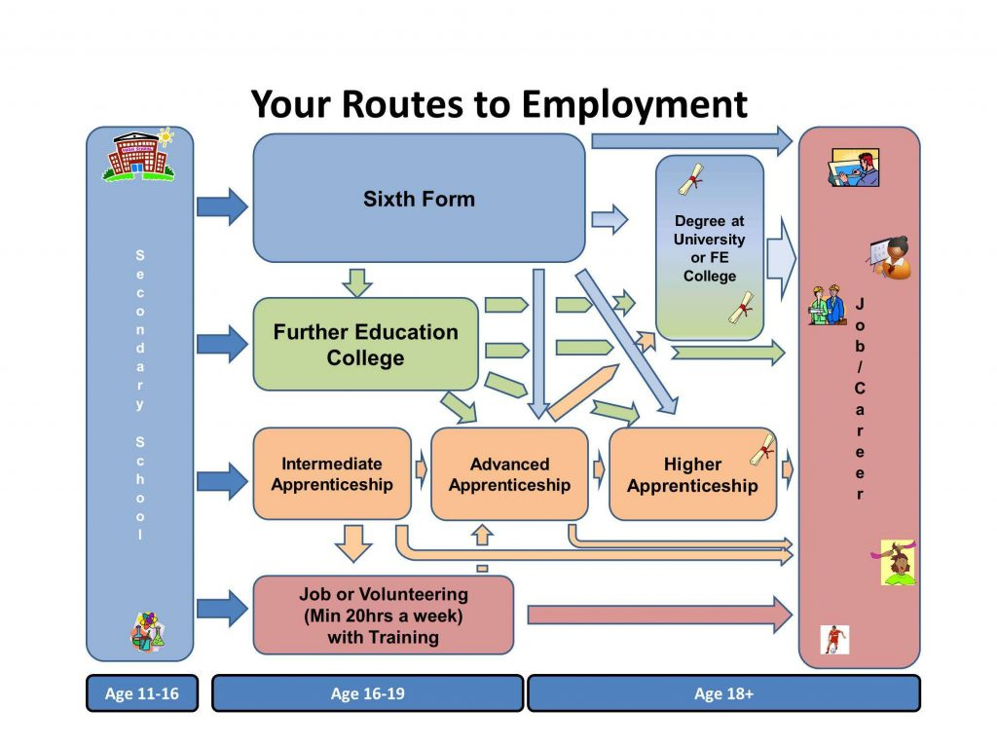



**Post-16 Education – What are my options?**



Since 2013, the Raising of the Participation Age law has stated that young people must be in some form of ‘education or training’ until they are 18. This can include:

**Full-Time Study** – this could be a qualification taken at a sixth form, college or training provider, totalling 540 hours of learning time per year, or around 18 hours per week.

**Apprenticeships** – this involves working for an employer while studying for a qualification as part of your training. Usually, work makes up 80% of an apprenticeship and at least 20% (or one day a week) should be dedicated to studying.

**Traineeships** – this is an option for students who would like to do an apprenticeship but may not have the experience, skills or qualifications to do so yet. Traineeships can last up to six months and involve a work placement, Maths and English qualifications and support with finding an apprenticeship.

**Part-Time Study with Employment or Volunteering** – this could be working in a full-time job (classed as any work that takes place over more than two months and is over 20 hours per week) or volunteering (again, over 20 hours per week) while studying part-time at a college or training provider (totalling 280 hours of learning per year).

**How do I pay for post-16 education and training?**

Education and training in the UK are free for young people until they turn 19. In addition, there is a **16-19 Bursary Fund** to help students from low income families pay for things like transport, food and stationery, which can be accessed at any sixth form, college or training provider you attend after Year 11 - [www.gov.uk/1619-bursary-fund](http://www.gov.uk/1619-bursary-fund)

If you receive financial benefits from the government, such as **Tax Credits** or **Child Benefit**, it is important that you are aware of how these can be affected once your child leaves school. If your child is in full-time education, such as sixth form or college, your benefits will remain the same but if your child progresses into paid employment or an apprenticeship, they will no longer be considered your dependant and your benefits for them will stop.

Many organisations also have their own financial support for students, so check first!

**Useful Links:**

<http://www.parentalguidance.org.uk/help-information/raising-the-participation-age-rpa>

<https://www.gov.uk/know-when-you-can-leave-school>



Sixth form colleges typically focus on A-Level (Advanced Level) qualifications – two-year courses that end in an overall examination and a grade from A*-E, with a similar structure to GCSEs but looking at the subject in a lot more depth. Students can choose Local Sixth Form or a Sixth Form College such as Havering College of Further and Higher Education, Havering Sixth Form, Sydney Russell Sixth Form, Cooper Coburn and Company Sixth Form etc.

Students can study:

**Traditional A-Levels** – Subjects like **Biology, Chemistry, Physics, English Literature, English Language, Mathematics, Geography, History, Languages, Religious Education, Music, Art**

**Alternative A-Levels** – Subjects like **Photography, Law, Sociology, Psychology, Business Studies, Film Studies, Media Studies, Economics, Politics, Sports Science – NOTE: AVAILABILITY OF THESE SUBJECTS IS DEPENDANT UPON TYPE OF COLLEGE/SIXTH-FORM THAT STUDENTS ARE APPLYING FOR.**

**BTEC L3 Diplomas** – Some sixth form colleges offer BTEC qualifications that can be taken alongside A-Levels. These are usually made up of a number of separate modules and include practical assessments and coursework, as well as exams. Subjects can include **Health and Social Care, Applied Science, Travel and Tourism and Engineering.**

Students studying A-Levels usually select three or four subjects (depending on their GCSE grades) that they want to study at sixth form and if they study four, can choose to drop one subject after their first year of sixth form. Students can also choose to study a one-year AS Level qualification, which is worth 40% of an A-Level. Sixth form colleges also offer something called the Extended Project Qualification (EPQ), an independent project that can provide students with UCAS points to put towards university.

**Entry Requirements** – Most sixth form colleges usually ask students to have 5 GCSEs at Grade 4/C or above but make sure that you do your research, as some courses, such as A-Level Maths, Physics, Biology and Chemistry, require students to achieve a Grade 6 at GCSE in order to demonstrate their deeper understanding of the subject.

Sixth Form Colleges



Colleges and Training Providers

Colleges and training providers usually offer BTECs or other vocational qualifications that focus on a specific area of study in a practical way, which can include:

**General FE Colleges –** Offer everything from **A Levels** to **Hair and Beauty**, **Childcare** and **Construction**, through to **Business Management**, **Games Design**, **Automotive Engineering, Food Technology**, **Fashion Design**, **IT,** **Performing Arts**, **Photography and many more**:

**Smaller Training Providers** – In addition to the larger FE colleges, there are a number of smaller training organisations around the city and further afield that offer a range of vocational courses for students, including ***Motor Vehicle***, ***Business Admin***, ***Customer Service***, ***Health and Social Care***, ***Construction***, ***Personal Fitness***, ***Hair and Beauty*** and ***Hospitality and Catering*** and help for students wanting to progress on to apprenticeships or work, all delivered in a much smaller environment with class sizes of 10-15 students

**Specific Vocational Colleges** – Offer courses such as Electrics, Railway Engineering, Construction, Hairdressing, Accountancy and many more

**Entry Requirements**:

**Entry Level/Level 1** – Can require anything from no qualifications up to 3 GCSEs (any grade)

**Level 2** – Usually requires 3 GCSEs at Grade 3/D or above

**Level 3** – Usually requires 5 GCSEs at Grade 4/C or above



T Levels are new courses coming in September 2020, which will follow GCSEs and will be equivalent to 3 A Levels. These 2-year courses have been developed in collaboration with employers and businesses so that the content meets the needs of industry and prepares students for work.

T Levels will offer students a mixture of classroom learning and ‘on-the-job’ experience during an industry placement of at least 315 hours (approximately 45 days). They will provide the knowledge and experience needed to open the door into skilled employment, further study or a higher apprenticeship.

For more information on T-Levels, check out the link below:

<https://www.gov.uk/government/publications/introduction-of-t-levels/introduction-of-t-levels>



Apprenticeships and Traineeships

**Apprenticeships** – Involve working for an employer in a specific role while being trained to do the job by experienced staff, in a combination of on-the-job and off-the-job training at a college or training provider (this must be at least 20% of the apprenticeship).

Apprenticeships must be at least one year long and all apprentices must be paid a minimum of £3.90 per hour (although many companies pay more – some pay over £1000 per month!). Apprenticeships can now be undertaken in a variety of industries, including **Engineering**, **Graphic Design**, **Software Development**, **Hair and Beauty** and **Catering**. These can be started as soon as an individual turns 16 and has left full-time education, although you can apply beforehand.

Apprenticeships come in four different levels:

**Intermediate/Level 2** (equivalent to GCSE) – usually requires Maths/English at GCSE

**Advanced/Level 3** (equivalent to A-Level) – usually requires 5 GCSEs at Grade 4+

**Higher/Level 4-5** (equivalent to Foundation Degree) – usually requires L3 or A-Levels

**Degree/Level 6-7** (equivalent to University Degree) – usually requires 3 A-Levels or similar

**Traineeships** – These are opportunities for students aged 16-24, who do not have the relevant qualifications, experience or skills to start an apprenticeship but are interested in progressing on to one in the future. **Traineeships** involve a programme of up to six months of study, including a work placement, qualifications in Maths and English and support with finding a job or apprenticeship once the course is completed. Students are not paid for taking part but can apply for a 16-19 Bursary Fund to help with costs.

**Apprenticeship Information:**

[www.apprenticeshiphub.org.uk](http://www.apprenticeshiphub.org.uk) <https://be-more.info/>

[www.gov.uk/apply-apprenticeship](http://www.gov.uk/apply-apprenticeship)

See Appendix 2 – 20 Things You Need To Know About Apprenticeships Factsheet

**Other useful Links:**

<https://amazingapprenticeships.com/>

<http://www.apprenticeshipguide.co.uk/>

<https://www.gov.uk/government/publications/a-parents-guide-to-apprenticeships>



**Applying for post-16 – How does it work?**

Students will begin applying for their post-16 options in autumn 2019 and the application process for sixth form, college and apprenticeships takes place throughout the course of the academic year. Here is a projected timeline for 2019-20:

**October 2019** – Sixth form and college courses for 2020-21 visible on application sites

**End of January 2020** – Closing date for Havering Sixth Form and Havering College applications

**NOTE**: Local School Sixth Forms and other local Colleges do not have the same deadlines and it advisiable to check with specific institutions using their individual websites - but early applications are still advised!

**February-March 2020** – Students are invited to sixth form/college interviews

**March 2020** – Students begin to receive offers from sixth forms and colleges

**March-July 2020** – Students accept or reject offers for different courses

**September 2020** – Applications for 2020/21 close

Applications for College / Sixth form can be submitted online on the respective websites.

**NOTE:** Apprenticeship and Traineeship applications run throughout the academic year with bigger companies starting the recruitment process much earlier – start looking in October 2019 for the big companies! Apprenticeships have a much more detailed application process than sixth form or college and require the completion of an application / submission of CV / Interview and in some cases an online ability test / assessment centre.

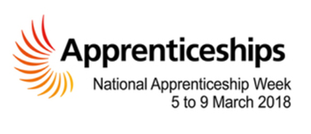





The great news is that you can apply and accept offers from as many sixth forms, colleges and training providers as you want and can then make your mind up about which one you want to progress on to in September after visiting the environment, meeting the staff and finding out what GCSE grades you have received in August 2020!

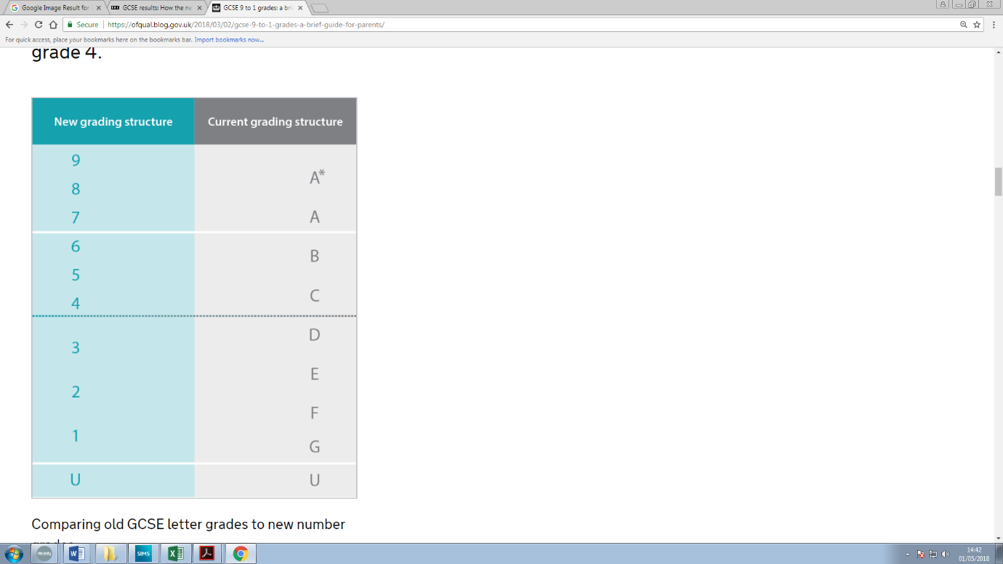

Entry Requirements – What do I need to get in?

The recent changes to the GCSE grading system have confused some people, so take a look at the information below to make sure you know what grades you might need to get at GCSE in order to move on to your chosen destination after Year 11:

**Do your research!**

No matter what you read online, it is important to check all information carefully. Although the Department for Education have stated that a Grade 4 will be considered the official ‘Pass Mark’ for students (<https://www.tes.com/news/new-gcse-pass-lowered-grade-5-4-dfe-u-turn>), not all colleges or universities may agree with this. For example, Kings College London and UCL both now ask for a Grade 5 at GCSE in English and Maths as part of their entry requirements, but Manchester, Leeds and Liverpool (all Russell Group universities) still consider Grade 4 the equivalent to a C.

**Use ALL the information available!**

As stated above, different post-16 and post-18 pathways may ask for different entry requirements depending on the course and/or college. For example, some apprenticeships require only GCSE English and Maths at Grade 3 (D) and above, while some sixth form colleges ask for a Grade 5/6 (high C/B) in the subject students are wanting to take up from GCSE to A-Level.

**Some useful references:**

**Which University – How important are my GCSEs?** <https://university.which.co.uk/advice/gcse-choices-university/how-important-are-my-gcse-grades>

**Ofqual** - <https://ofqual.blog.gov.uk/2018/03/02/gcse-9-to-1-grades-a-brief-guide-for-parents/>

**The Student Room** - <https://www.thestudentroom.co.uk/gcse/exams/new-gcse-grades-explained>

**Key Points:**

* A **Grade 4** is a ***Standard Pass***, while a **Grade 5** is a ***Strong Pass***
* Only around 2-3% of students will achieve a **Grade 9**, making it a little higher than the old **A\***
* Although the new grades don’t exactly match the old grades, colleges will mostly view them as follows:

**9-7** = A*- A **6** = B **4-5** = C **3-1** = D and below

* Vocational qualifications like ***BTEC*** and ***VCERT*** match up with GCSEs as follows:

**Level 1** = GCSE grades 1-3 (Level 1 Pass - Distinction)

**Level 2** = GCSE grades 4-9 (Level 2 Pass – Distinction)

* Most colleges, sixth forms and apprenticeships accept BTEC-type qualifications, as do **95%** of universities, including the Russell Group and Oxford!

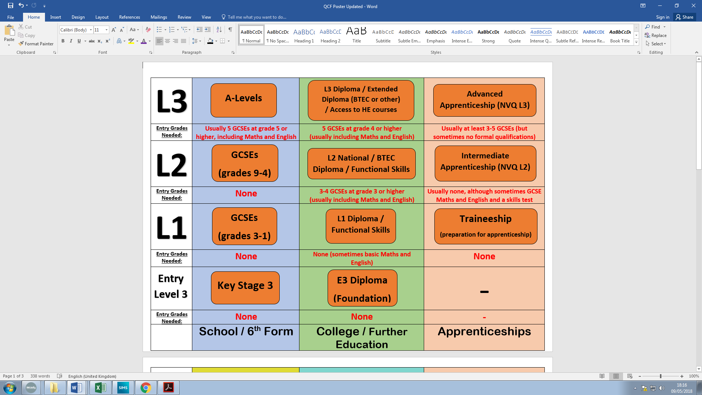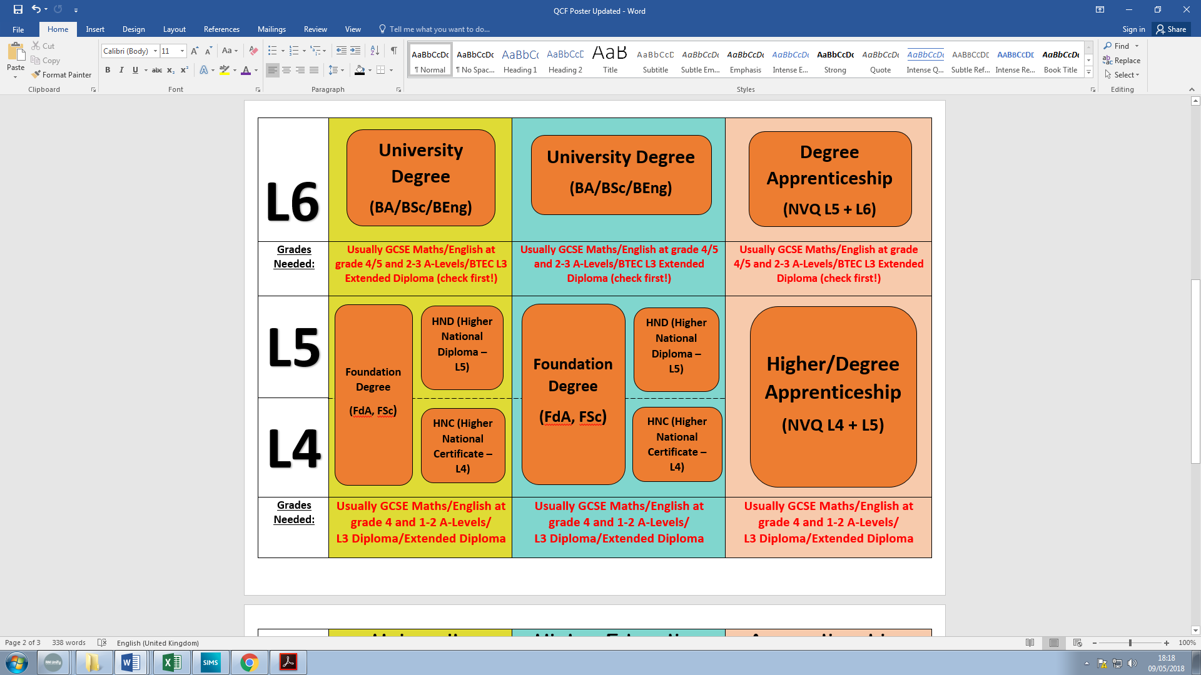

**Qualification Levels Guide – GCSE to Degree Level**



**How do I make my final decision about post-16?**

Making a decision about where to go after Year 11 can be tricky, particularly while you are busy revising for your final GCSE exams, so it is important to consider the following factors that might help with decision making:

* **Where can this option take me in the future?** If you are thinking about a destination after post-16, such as university or higher/degree apprenticeships, it is important to know whether the qualifications you are taking from 16-18 can help you to progress on to these pathways. Use websites like the Russell Group’s **Informed Choices** (<https://www.informedchoices.ac.uk/>) or **Success at School** (<https://successatschool.org/>) to find out whether the course you choose after Y11 will allow you to progress on to what you want to do or speak with staff at the sixth form, college or apprenticeship you are applying to in order to get further details!

For example:

* **If you want to study Dentistry at university, you usually need to take A-Levels in Chemistry and Biology/Maths/Physics.**
* **Some universities do not accept BTEC L3 Extended Diplomas (although 95% do!)**
* **Apprenticeships have varying entry requirements – some ask for 5 GCSEs at Grade 4 or above while others ask for 2-3 A-Levels**
* **What will doing this option be like?** Whatever you choose to do after Year 11, you will probably be doing it for at least one year, so it is important that you know that the learning environment and style of learning will be right for you. Why not…
* **Speak to sixth form or college staff and students at one of the many Open Days or Open Evenings (see Appendix 1 for Open Day/Evening Events for local colleges and Sixth Forms) that take place throughout the year – the websites for each sixth form or college will have these dates on but you can also use** [**https://www.opendays.com/**](https://www.opendays.com/) **to help make your search easier!**
* **Research more about the sixth form, college or apprenticeship provider online to find out about what you would study as part of your qualification or what support the organisation can provide you with while you are studying e.g. help finding work experience, financial support like a free bus pass or food allowance, assistance from the careers team to help you move on after finishing your course etc. Sixth form and college websites have all the information you need!**

Want to get prepared over the course of this academic year?



Search and apply for apprenticeships online – <https://www.apprenticeships.gov.uk/>



Learn more about the options available after finishing school, including sixth form, college, apprenticeships and university – https://careerpilot.org.uk/



Free careers software to help you connect your skills, hobbies and subject interests to what you might want to do once you leave school – <https://www.startprofile.com/>



Start volunteering to gain valuable work-related skills and experience – <https://vinspired.com>



Improve your employability skills and start recording your experiences in a CV – [www.barclayslifeskills.com](http://www.barclayslifeskills.com)



##### Use Informed Choices digital tool to help you understand which A Level and BTEC subjects open up different degrees, particularly at Russell Group universities - [**https://www.informedchoices.ac.uk/**](https://www.informedchoices.ac.uk/)You can also use UCAS.com



The school Careers Adviser will be working with all Year 11 students from September but you can also email [devans@hornchurchhigh.com](mailto:devans@hornchurchhigh.com) with any questions!

Appendix 1 – College Open Events

**Colleges in the area**

**Barking and Dagenham College**  Thursday 31st October 2019 4pm Thursday 5th December 2019 4pm

**The Technical Skills Academy** (operated by Barking and Dagenham College) Thursday 10th October 2019 4pm

**Havering College of Further & Higher Education**

**Ardleigh Green Campus** Sat 16th November 10am-2pm

Thursday 16th January 2020 4pm-7pm

Saturday 28th March 2020 10am-2pm

Tuesday 9th June 2020 4pm-7pm

**Quarles Campus** Sat 16th November 10am-2pm

**Rainham Campus** Sat 16th November 10am-2pm

**Havering Sixth Form College**  Saturday 16th November 2019 10pm-3.30pm

**Palmer’s College** 10th October 6- 8:30pm

28th November 6-8:30pm

30th January 6-8:30pm

**SEEVIC** 3rd October 2019 6pm-8pm

19th November 2019 6pm-8:30pm

6th February 2019 6pm-8:30pm

**Redbridge College** Saturday 16th November 2019 10am-1pm

Tuesday 26th November 2019 5pm-7pm

Wednesday 5th February 2020 5pm-7pm

Saturday 28th March 2020 10am-1pm

Wednesday 17th June 2020 5pm-7pm

**South Essex College**

All **Southend Campus** Wednesday 9th October 2019 5pm-8:00pm Thursday 14th November 2019 5pm-8:00pm

Tuesday 17th March 2020 5pm-8:00pm

**Basildon Campus**  Tuesday 22nd October 2019 5pm-8:00pm

Wednesday 11th March 2020 5pm-8:00pm

**Thurrock Campus** Thursday 17th October 2019 5pm-8:00pm

Wednesday 15th January 2020 5pm-8:00pm

Tuesday 12th May 2020 5pm-8:00pm

**Local School 6th Forms**

**Campion (Girls accepted in 6th Form)** Wednesday 4th December 2019 6pm

**Coopers Company and Coborn** Thursday 28th November 2019 4pm

**Drapers Academy** Monday 25th November 2019 6pm-8pm

**Frances Bardsley Academy for Girls** Wednesday 13th November 2019 6:30pm-9:00pm Thursday 21st January 2020 2:10- 4:30pm

**Sacred Heart School for Girls** Thursday 7th November 2019 7pm onwards

**St Edward’s Church of England School** Thursday 31st January 4pm – 7pm

**Other school 6th Forms in Essex, Thurrock and Barking & Dagenham**

**Ockendon Academy** Thursday 17th October 2019 5pm-7pm

**Harris Academy**  Thursday 26th September 2020 5pm

Wednesday 20th November 2019 5pm-8pm

**St Martins School** Wednesday, 15 November 5pm-7pm

**Brentwood Ursuline Convent School** Wednesday 6th November 2019 6:30pm-8:30pm

**Brentwood County High School** Saturday 28th September 2019 10am-1pm

**Shenfield High School** Thursday 14th November 2019 6.15pm-8.00pm

**Anglo European School**  Thursday 26th September 2019 6:30pm- 8:30pm

**Becket Keys School** 25th September 2019 Time TBC

2nd October 2019

**Grammar Schools (High entry grades required)**

**King Edward V1 (KEGS)** Monday 10th December 5.00pm

**Chelmsford County High School for Girls** Monday 14th October 5pm-8pm

**Westcliff High School for Girls**  Tuesday 12th November 2019 7pm-9pm

**Westcliff High School for Boys**  Thursday 14th November 2019 6:30pm-9pm

**Southend Schools for Boys** Thursday 7th November 2019 5:30pm-7:30pm

**Southend School for Girls** Thursday 1st November 2019 6pm-8pm

**Colchester Royal Grammar School** Tuesday 22 October 6.30pm -9.00pm.

**Ilford County High for Boys** Thursday 5th December

**Woodford County High School for Girls** TBC

**Highly rated sixth form/colleges (High entry grades required)**

**Brampton manor school (Newham)** Thursday 21st November

**Seven Kings High School (Seven kings)** TBC

**Oaks Park High schools (Newbury park)**  28th November 3.30-6.30pm

**London Academy of Excellence (Stratford)** Wednesday 30th October

Wednesday 13th November

Saturday 23rd November

**Kings College London Maths School** (maths, physics and computing)

Open evening 1st October 5pm

Taster day 12th October 10am

**Newham collegiate sixth form** (sciences) Thursday 28th November 5pm-8pm

Thursday 5th December 5pm-8pm

**Specialist Colleges**

**Access to Music**

Shoreditch Campus- London Shoreditch

Book on to Open Day via telephone or online

Tuesday 22nd October 2019 3:00pm, 4:30pm or 6:00pm

**Big Creative**

Wednesday 16th October 4:30pm-7pm

Wednesday 13th November 4:30pm-7pm

Wednesday 11th December 4:30pm-7pm

Wednesday 15th January 4:30pm-7pm

Wednesday 12th February 4:30pm-7pm

Wednesday 18th March 4:30pm-7pm

Wednesday 22nd April 4:30pm-7pm

Wednesday 13th May 4:30pm-7pm

Wednesday 17th June 4:30pm-7pm

Wednesday 15th July 4:30pm-7pm

*Please register your attendance at* [*http://www.bigcreative.education/*](http://www.bigcreative.education/)

**Brit School**

Book online

Thursday 26th September 2019 4-8:30pm

*The Brit School is a free Performing Arts and Technology School. It is an independent state funded City College for the Technology of the Arts.*

**Elutec** 26th November 2019 5pm-7pm

*Elutec is a University Technical College for students aged 14 to 19 years old specialising in Engineering, Design and Technology.*

**ELAM** – East London Arts and Music

TBC

**London College of Beauty Therapy**

Book in for an appointment for their open days

*London College of Beauty Therapy offers courses and apprenticeships in Beauty Therapy, Hair & Media Make-up, Hairdressing and Fitness.*

**Fashion Retail Academy** 19th October 2019

L2 & L3 - 10:00am prompt – Need to register online to book

*FRA is a private training provider which offers free government funded places on full-time further education courses. It offers a range of vocational and work-orientated courses for employment in the fashion retail sector.*

**PROCAT** – Engineering and Construction Wednesday 15th October 2019 4pm-8pm

Please register your attendance at http://www.procat.ac.uk/events

**Writtle College**

Saturday 7th September 2019 10am-1pm

Saturday 8th November 2019 10am-1pm

Saturday 11th January 2020 10am-1pm

*Writtle College offers a range of Further Education courses including Animal and Equine Sciences, Conservation, Countryside, Sport, Horticulture, Veterinary Nursing, Veterinary Physiotherapy, Design, Agriculture and Floristry.*

Appendix 2 - Want 20 Things You Need To Know About Apprenticeships

Apprentices train on the job, working with an employer to pick up the skill they need for their chose career

**As an Apprentice you study (either at college or with a Training Provider) to gain nationally-recognised qualifications**

**Apprentices are paid for their work. The amount varies. Any apprentice, regardless of age, is paid £3.90 per hour in the first year of their apprenticeship. The minimum after that for under 18s is£4.35, for 18-20 year olds is £6.15 and £7.70 if you are over 21, but it can be much more than that**

**Apprentices can also get a Degree Apprenticeship. They do just what they say on the tin: you get a degree (a Bachelors or Masters, depending on the level you go for) via the Apprenticeship route. Except all your costs are paid for. That's right – a fee-free degree**

**No student loan required! You earn as you learn on an Apprenticeship, and your employer covers your training costs**

**Major employers hire Apprentices, including the BBC, Barclays, IBM and Google**

**Employers offer apprenticeships in more than 170 industries, with some 1500 job roles available. You could train to be anything from an accountant to a youth worker, an engineer to a veterinary nurse**

**Apprenticeships are available at three levels: Intermediate Level 2 (equivalent to GCSE), Advanced Level 3 (equivalent to A Levels) and Higher Levels 4-7. Higher and Degree Apprenticeships are equivalent to university-level study, from Foundation to Masters Degree**

**Apprenticeships last for at least a year and can continue for up to five years**

**Anyone over 16 living in England can apply to be an Apprentice. If you live in Scotland, Wales, or Northern Ireland, check out your apprenticeship options locally**

**As an Apprentice you study (either at college or with a Training Provider) to gain nationally-recognised qualifications**

**If you're not quite ready for an Apprenticeship, a Traineeship can help young people aged 16-24 get the skills and experience needed, for an apprenticeship or the world of work**

**Apprentices can earn more. On average, Higher Apprentices earn £150,000 more over their lifetime than those with Level Three vocational qualifications**

**Forget all that old-fashioned stereotyping of Apprenticeships as only being good for learning a trade. The most popular sector is health and social care, but business, finance, engineering and construction are growing**

**Apprentice and school leaver recruitment in 2018 was 50% higher than 2017, a much faster rate than the growth in graduate hiring**

**Nine out of ten Apprentices say they are satisfied with their Apprenticeship**

**Most employers retain their apprentices as employees, seeing them as a way to deal with skills gaps and bring in fresh thinking**

**Apprentices receive at least 20 days of paid holiday, plus bank holidays**

**There were 375,800 apprentice starts last year**

**Forget all that old-fashioned stereotyping of Apprenticeships as only being good for learning a trade. The most popular sector is health and social care, but business, finance, engineering and construction are growing**

**Apprentices get an NUS card, just like any other student, which entitles you to cheaper travel and discounts in various stores**

**Apprentices work at least 30 hours a week**